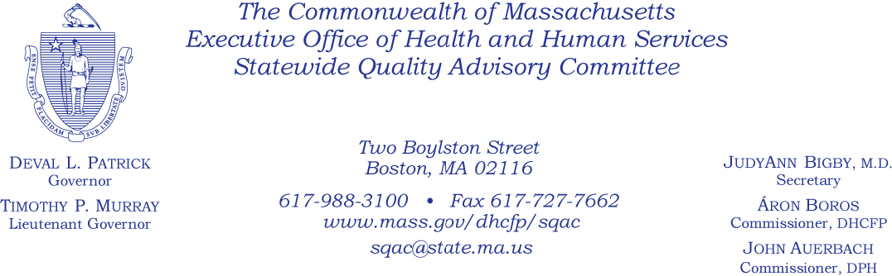

Meeting Agenda

February 21, 2012

1. Approval of minutes of January 25, 2012 (Committee)

2. Approval of bylaws

3. Review mandated measures and present preliminary validity/practicality assessment (J.
Freedman)

a. CMS Hospital Process Measures
b. H-CAHPS (Hospital Consumer Assessment of Healthcare Providers and Systems
Survey)
c. HEDIS (Healthcare Effectiveness Data and Information Set)
d. Ambulatory Care Experiences Survey

4. Discussion and identification of outstanding questions on validity/practicality assessment of measures (Commissioners/Committee)

5. Next steps

