Measuring Health Confidence
Additional Considerations for the
Statewide Quality Advisory Committee

October 21, 2013: John H. Wasson, MD present.

The SQAC received a report prepared by the Lewin Group on September 25th that looked at a number of recommended assessment measures, including patient health confidence. We feel additional considerations ought to be included in any evaluation of the patient health confidence measure, and urge the Lewin Group and SQAC to consider the evidence we are presenting as part of its decision process.

The considerations are:
- Based on Lewin’s methods Health Confidence should score quite well (see Attachment One). It has been widely implemented since 2003 and it was recently used by Harris International in a population survey of 11 industrialized nations.
- The measure “operationalizes and synthesizes” the critical concepts from the evidence-based Chronic Care Model for improving personal and population health. The concepts have been called, at various times, “productive interactions”, “engagement”, “self-efficacy”, “activation”, or “self-management.” There is no comparable, single measure available in the public domain.
- The measure is interpretable and actionable by the individual, a health professional or a policymaker. For example, Massachusetts General’s Practice of the Future just began using a variation of it for this purpose. (Verbal Communication: Steven Lynch). It has long been used to assess and activate hundreds of thousands of people for better control of health habits and bothersome problems. (In HowsYourHealth.org).
- Improvement in health confidence is associated with improved outcomes; low confidence is associated with higher costs of care.
- Most importantly, from a political and practical perspective, organizations in Massachusetts and elsewhere are planning a Campaign for Health Confidence. For example, Health Care for All is currently using the measure to activate and support the Massachusetts-legislated Patient and Family Advisory Councils. (See Attachment Two)

Therefore, we ask your group to endorse the health confidence measure for the improvement of population and personal health and health system quality. Because of the likelihood of adverse unintended consequences we do not with this measure used for payment.

Thank you for your consideration.

Attachment One
Health Confidence Measure

- The proposed measure is a single item for use both as a measure for practice performance and individual self-rating. Because it is a single measure it is very easy to administer and use. [The measure has been used in multiple languages in international settings.] (1)

- This single measure at the individual and population level can be used to document change over time. (2,3)

- At the practice level it can be used to document change. (4)

- The measure “operationalizes and synthesizes” important behavioral concepts such as engagement, productive interaction, or activation. (1,4,5) There are no other single item measures for these concepts with as long history (since 2003).

- In addition to the face validity inherent in observations described previously a single measure correlates to six items for “confidence” from a widely used multi-item measure (criterion validity). (1,6) Diabetics who are persistently confident over a two-year period have much better blood sugar control than patients who are not confident over the same period of time. (3) Better outcomes of patient self-management disease control (such as cholesterol and blood sugar levels or engagement in exercise) are observed in practices having patients who attain higher levels of health confidence (after adjustment for demographics, financial status, and illness burden). (5)

Use of Single Item Measure for Health Confidence
(Based on either ordinal or interval scoring)
Criteria  (Lewin Associates) | Documentation | Reference Number | Revised  Lewin  Score
Ease of Measurement | Very High because it is self-scored and face interpretable. Has been used in 11 international surveys. | 1 | 3-4/4
Validity and Reliability. | Criterion validity against multi-items of the same concept. Construct validity (with blood sugar control) in diabetic patients and (with other measures of outcomes of patient-self-management) in practices attaining higher levels of patient-reported health confidence. | 1,3,5,6 | 2/4
Field Implementation | Since 2003 used in office practices, hospitals and nations. | 1-5, 7-9 | 3-4/4
Amenable to Intervention | In clinical use the measure changes over time in the expected direction. | 2-4 | 3-4/4

++++++++++++++++++++++++

1. Wasson JH. A Patient-Reported Spectrum of Adverse Health Care Experiences:
Harms, Unnecessary Care, Medication Illness, and Low Health Confidence. 2013. J Ambulatory Care Manage: Vol. 36, No. 3, pp. 245–250
2. Wasson JH, Anders GS, Moore LG, Ho L, Nelson EC, Godfrey MM, Batalden PB. Clinical Microsystems, Part 2. Learning from Micro Practices about Providing Patients the Care They Want and Need. Joint Commission Journal of Quality and Patient Safety 2008;34:445-452
3. Wasson JH, Johnson DJ, and Mackenzie T. The Impact of Primary Care Patients’ Pain and Emotional Problems on their Confidence with Self-Management. Jamb Care Mngmnt. 2008;31: 120-127.
4. Lynn Ho, MD; John Watt Haresch, MD; Mark Nunlist, MD; Adam Schwarz, MD; John H. Wasson, MD. Improvement of Patients’ Health Confidence: A Comparison of 15 Primary Care Practices and a National Sample. 2013. J Ambulatory Care Manage. Vol. 36, No. 3, pp. 235–240
5. Wasson JH, Benjamin R, Johnson D, Moore LG, and Mackenzie T. Patients Use the Internet to Enter the Medical Home. J.Amb.Care.Mgmt. 2011; 34:38-465.
6. Hibbard, J. H., Stockard, J., Mahoney, E. R., & Tusler, M. (2004). Development of the patient activation mea- sure (PAM): Conceptualizing and measuring activation in patients and consumers. Health Services Research, 39(4), 1005–1026.
7. Luce P, Phillips J, Benjamin R, Wasson JH. Technology for Community Health Alliances. J. Amb. Care Managem. 2004;27(4): 366-374
8. Yasaitis L, Fisher ES, Mackenzie T, and Wasson JH. Health Care Intensity is Associated with Lower HealthCare Quality by Adults. J.AMB.CARE.MGMT. 2009; 32: 226-231
9. Lepore M, Wild D, Gil H, Lattimer C, Harrison J, Woddor N and Wasson JH. Two Useful Tools To Improve Patient Engagement and Transition from the Hospital. 2013. J Ambulatory Care Manage. Vol. 36, No. 4, pp. 338-344

Example of Ease of Use (for Public Self-rating)
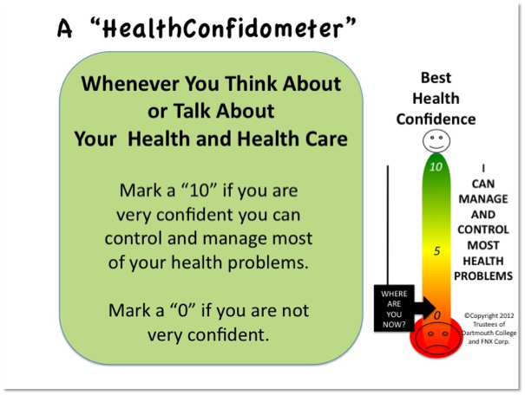

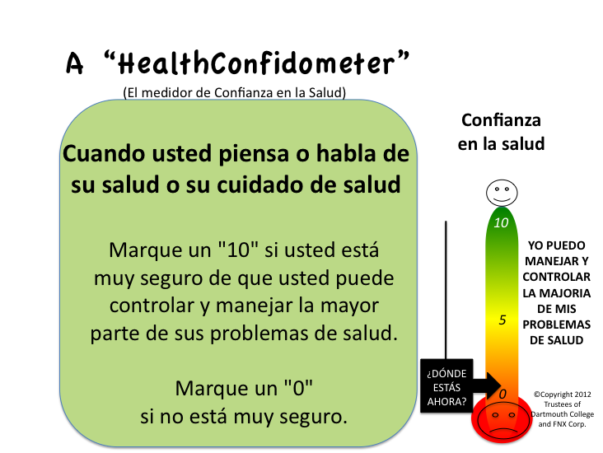

An illustration in change of the measure over time (percentage rating themselves as very confident). See reference 2 .
