Massachusetts All-Payer Claims Database:
Technical Assistance Group (TAG)
July 8, 2014

Agenda
- ACA Membership Reporting
- NAIC Code (PR017)
- Connector/Risk Adjustment
- QA Profile Reports
- Compliance
- Retaining Copies of Data
- Questions

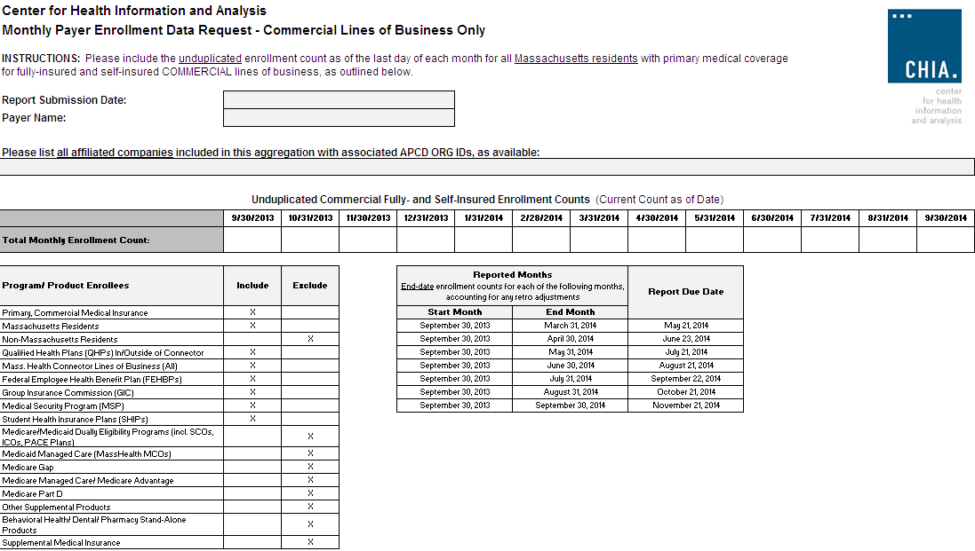

NAIC Code (PR017)
- National Association of Insurance Commissioners’ Code NOT the North American Industry Classification System (NAICS)
- Will be used by Division of Insurance and the Connector

Connector/Risk Adjustment
Next Simulation:
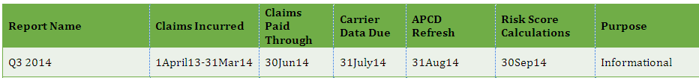

V2 to V3 Profiles
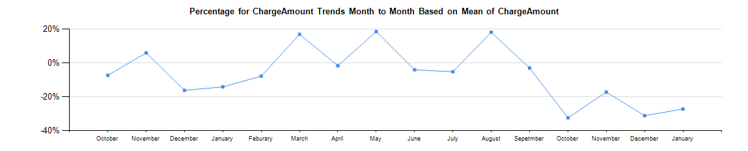

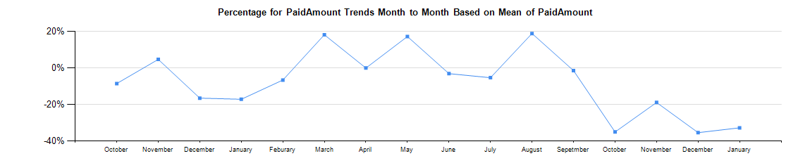

Additional QA Profile Reports
CHIA is planning to share new profile reports with carriers next month for review before publishing on CHIA’s website. These profiles are based on 2012 incurred data and will be sent to the top submitters based on medical claims volume.

Version 3 Compliance
We are looking to have all carriers in full compliance by July with production data through June 2014.

Retaining Copies of Data
Carriers should maintain copies of the data sent to CHIA

Upcoming Events
- End July/Early August – APCD Membership comparison to aggregate monthly reporting to CHIA
- August – Profile Reports – will preview on August TAG call and then send to carriers
- August/September – Connector Risk Assessment Simulation

QUESTIONS?

Next Meetings
August 12, 2014 at 2:00pm
September 9, 2014 at 2:00pm

